# Report on the Two-Tank System Simulation in Ptolemy II

W1269 Simulation Engineering

Assignment 2

Yousef Al-Hadhrami

600558

## Objective:

To simulate a hybrid automaton model of a two-tank system in Ptolemy II to maintain the water volume in each tank above a specified threshold by controlling the inflow dynamically.

## Problem Description:

The system comprises two tanks with constant leakage rates. Water is added to the system at a constant rate and directed to one of the two tanks based on volume thresholds. The simulation must ensure that:

* Tank 1 is filled if its volume (χ₁) falls below r1.
* Tank 2 is filled if its volume (χ₂) falls below r2.

Parameters provided are:

* r1: 0
* r2: 0
* v1: 0.5
* v2: 0.5
* w: 0.75

Initial conditions:

* x1: 0
* x2: 1

Simulation duration: 100 seconds.

**Hybrid Automaton Diagram:**

The hybrid automaton governing the two-tank system is depicted below:

Figure 1 Hybrid Two Tank System Automation

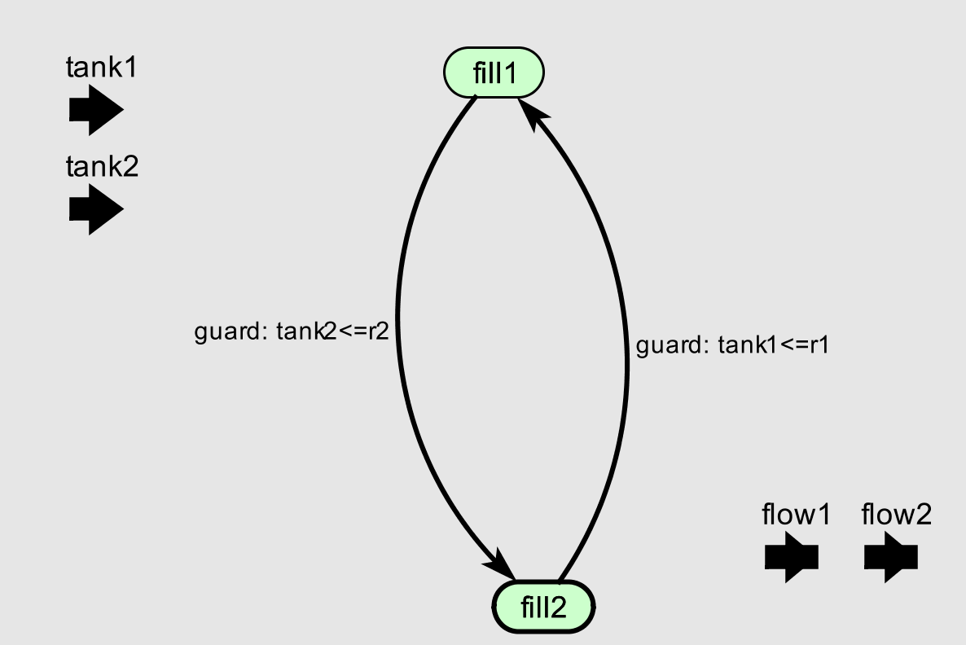

Figure 2 State diagram with the two states and switching conditions

In this diagram:

* State: Water flows into Tank 1, and Tank 2 leaks.
* State: Water flows into Tank 2, and Tank 1 leaks.

Transitions between states occur based on the conditions:

* Transition to fill1 when tank1<=r1.
* Transition to fill2 when tank2<=r2.

Figure 3 fill1 and fill2 diagrams showing the constant flow and outflow

## Results

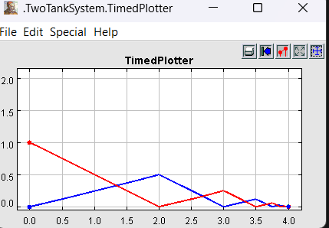

Figure 4 Plot showing the shifting of the flow between the two tanks

The graph shows how water levels in two tanks change over time:

* **Blue line (Tank 1):** Water level decreases due to outflow but increases when inflow starts if it drops below a set limit (r1).
* **Red line (Tank 2):** Water level follows a similar pattern based on the flow rates and control rules.

As time passes, you can see how inflow and outflow interact, switching states to keep water levels above the set thresholds. Small water level changes happen due to balancing inflow and outflow.

This model effectively demonstrates how two connected tanks manage water levels under the given conditions.